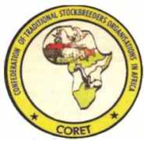
Confederation of Traditional Stockbreeders Organizations in Africa (CORET) is a pan African herders’ organization based in Kaduna, Nigeria with aim of promoting the traditional animal husbandry and conditions for its evolution. This aim will be achieved through consideration of issues related to natural resources and land management as well as socio-dynamics of herders in Africa.
CORET is pleased to be associated with the International Year of Rangelands and Pastoralists (IYRP), we strongly support this initiative.
Thank you.
Mohammed Bello Tukur
Ag. Secretary General CORET
Suite 507/508 Bank of Industry Building,
Muhammadu Buhari Way, Kaduna, Nigeria
+2348033046365
+2348080861666
secgencorte@gmail.com
coret_africa@yahoo.com

